# CHA2555 Artificial Intelligence

# **Practical 17: Linear Regression-2**

**Activity 1: Running Kahoot Quiz of Linear Regression Models**

# **Activity 2: Building the Linear Regression Model**

**Objective**: In this lab, you will examine **Linear Regression** classifier using airlines data (numeric attributes only).

1. Click the “***Open file,*** button and open Airline.arff data set (from Brightspace Week10_Unit-2), which consists of passenger and their date of travel. **Look at it; visualize it**.
2. Select *Choose* in the *Classifier* frame at the top and select ***classifiers > functions > Linear Regression model*.**
3. In your test option choose **10 cross validation** (to train your model) **> click start**
4. Predict passenger_numbers: classify with LinearRegression by right click on the model > visualise classifier errors ; set X label as Date and Y label as predicted passenger number

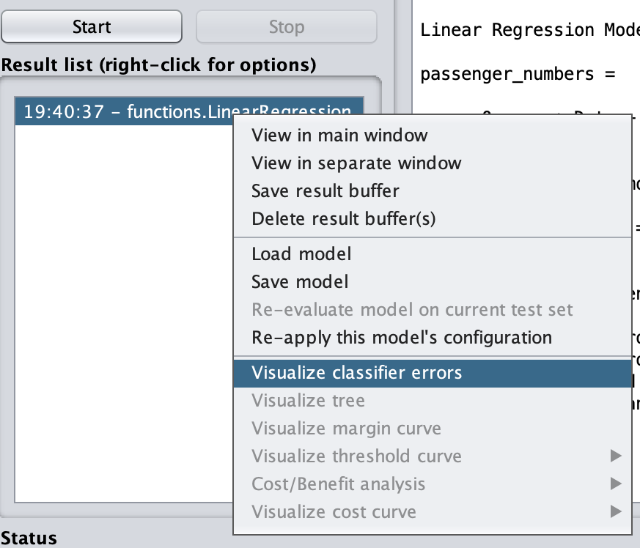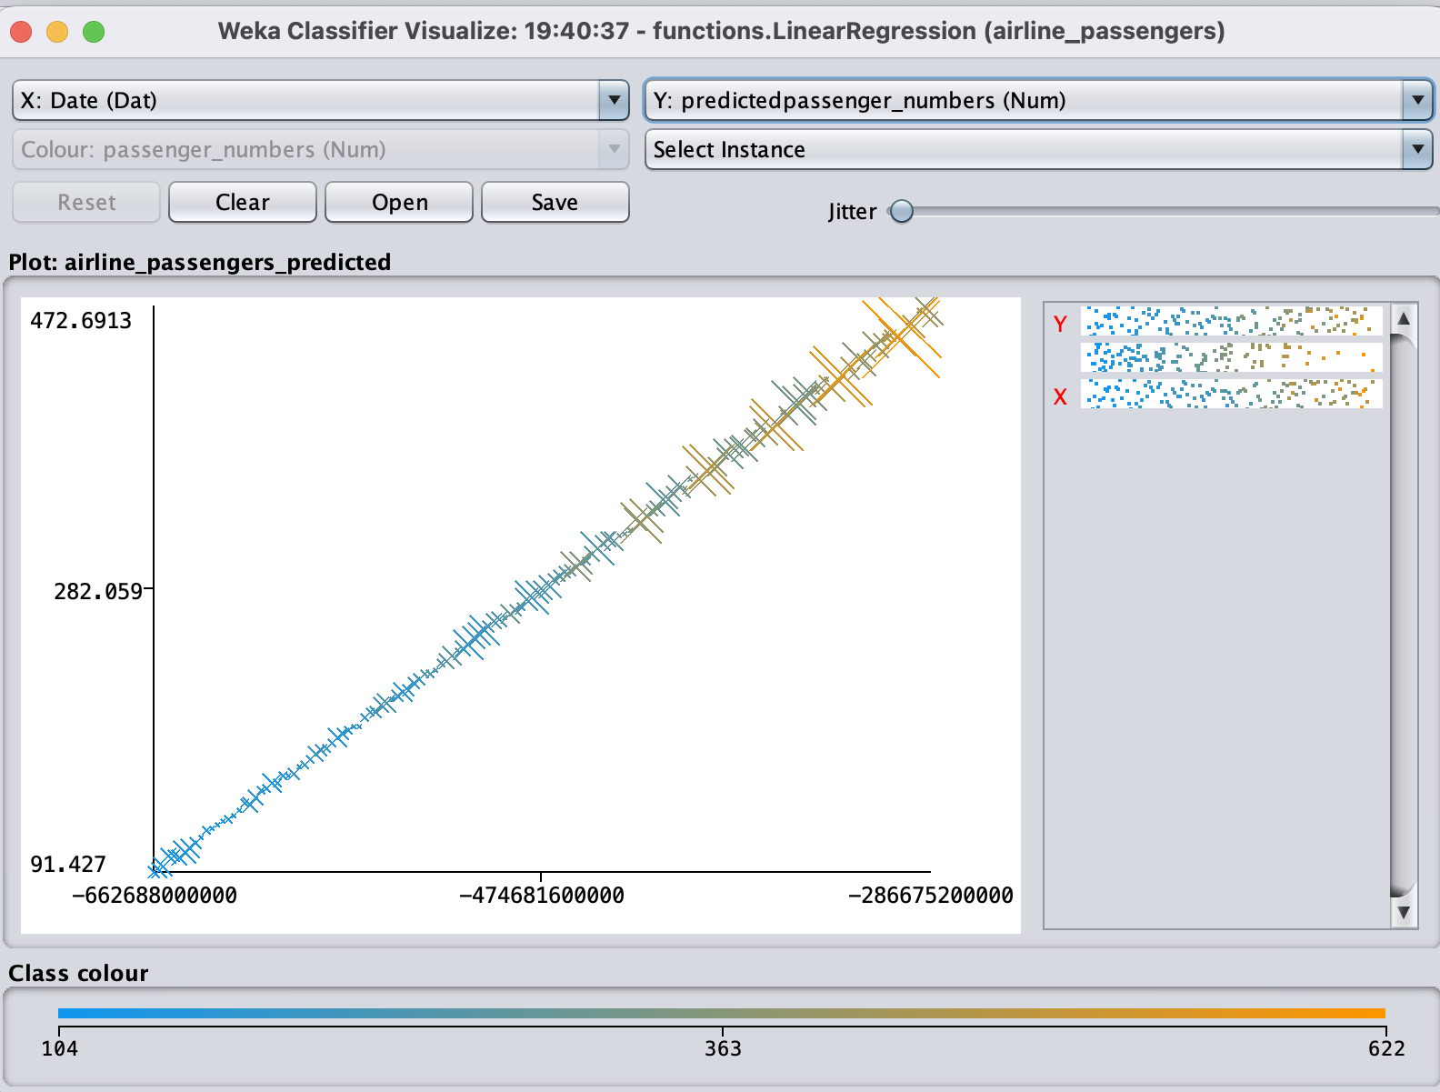

1. Re-map the date: millisecond since Jan 1, 1970 -> months since Jan 1, 1949 –

***Preprocess > filter > unsupervised > attribute >***  AddExpression > click Apply

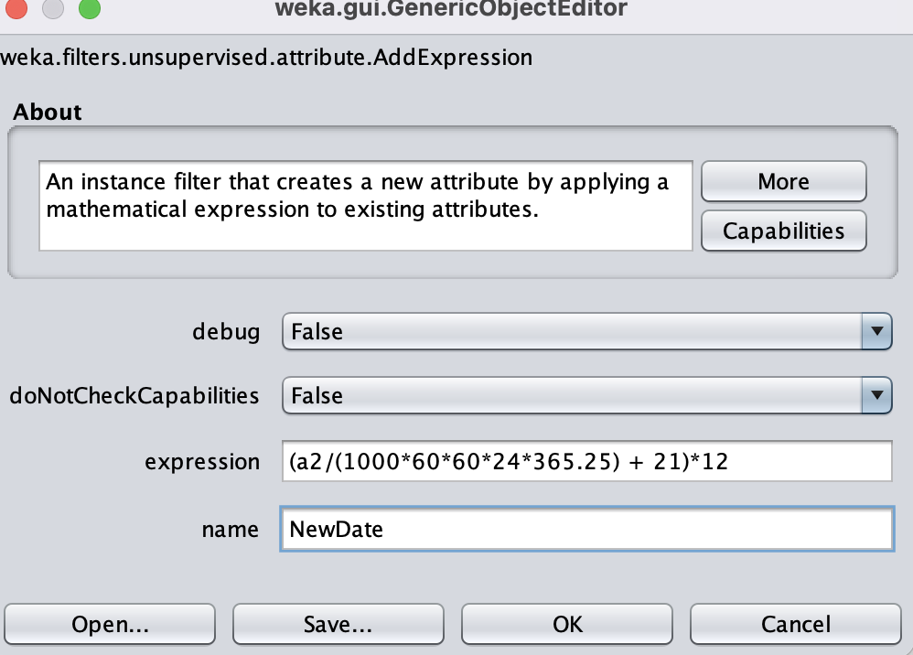(a2/(1000*60*60*24*365.25) + 21)*12; call it NewDate

1. Remove Date attribute
2. Re-build Linear Regression Model **> choose** passenger_number as prediction label
3. Study the previous linear regression model with the new model. Note down the **Root Mean Squared Error (RMSE), Mean Absolute Error (MAE) and Correlation Coefficient (CC**). Comment on each in comparison (in 2-3 sentences) and highlight what you have obtained for the SimpleLinearRegression model in **step 3 and 7**.

**Activity 3:**

1. Click the “***Open file,*** button to load [house](https://brightspace.hud.ac.uk/d2l/le/content/225791/viewContent/1992741/View) dataset (from Brightspace Week10_Unit-1). Study your dataset as shown in below table.

1. Repeat Activity 2 > step 2, but this time choose use *training data* (to develop your model) and your prediction label should be ***selling price*** and click start.

1. The prediction **of your selling Price** would be based on the following computationbased on your new data (e.g., houseSize, lotSize, bedrooms, bathroom)

**sellingPrice** = - 26,68 * [houseSize = 3198] + 7,05 * [lotSize = 9669] + 43.166,07 * [bedrooms = 5] + 42.292,09 * [bathroom = 1] - 21.661,12 = 219.328,25

Calculate weights from training data

Predicted value for first training attribute **a(1)**

Now If we provide the following test set we should be able to get this value 219.328,25 to sale our house.